**Project Design Phase-I Solution Architecture**

|  |  |
| --- | --- |
| DATE | 09 OCTOBER 2022 |
| TEAM ID | PNT2022TMID22590 |
| PROJECT NAME | PROJECT – SMART FASHION RECOMMENDER APPLICATION |
| MAXIMUM MARKS | 4 MARKS |

**Solution Architecture:**

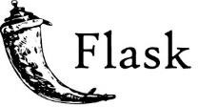



USER

Explores the website

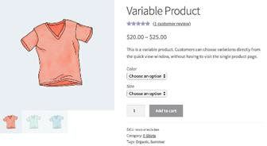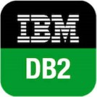

Information Resources

Product details

Website

Recommendation

Chatbot



CHOOSES PRODUCT

USER INTERFACE

User

satisfied

?

YES

NO





DELIVERY SHIPPING PAYMENT OPTION